Count Employees in Department

# Objective

Simulate a stored procedure to count the number of employees in a department using SQLite.

# Database Schema

Departments:  
CREATE TABLE Departments (  
 DepartmentID INT PRIMARY KEY,  
 DepartmentName VARCHAR(100)  
);  
  
Employees:  
CREATE TABLE Employees (  
 EmployeeID INT PRIMARY KEY,  
 FirstName VARCHAR(50),  
 LastName VARCHAR(50),  
 DepartmentID INT,  
 Salary DECIMAL(10,2),  
 JoinDate DATE,  
 FOREIGN KEY (DepartmentID) REFERENCES Departments(DepartmentID)  
);

# Sample Data

INSERT INTO Departments VALUES  
(1, 'HR'), (2, 'Finance'), (3, 'IT'), (4, 'Marketing');  
  
INSERT INTO Employees VALUES  
(1, 'John', 'Doe', 1, 5000.00, '2020-01-15'),  
(2, 'Jane', 'Smith', 2, 6000.00, '2019-03-22'),  
(3, 'Michael', 'Johnson', 3, 7000.00, '2018-07-30'),  
(4, 'Emily', 'Davis', 4, 5500.00, '2021-11-05');

# Simulated Stored Procedure Logic

SQLite does not support stored procedures directly, so we use a query with a WHERE clause to simulate it.

SELECT   
 D.DepartmentName,  
 COUNT(E.EmployeeID) AS TotalEmployees  
FROM   
 Employees E  
JOIN   
 Departments D ON E.DepartmentID = D.DepartmentID  
WHERE   
 D.DepartmentID = 3 -- Change this value to test other departments  
GROUP BY   
 D.DepartmentName;

# Output (Screenshot)

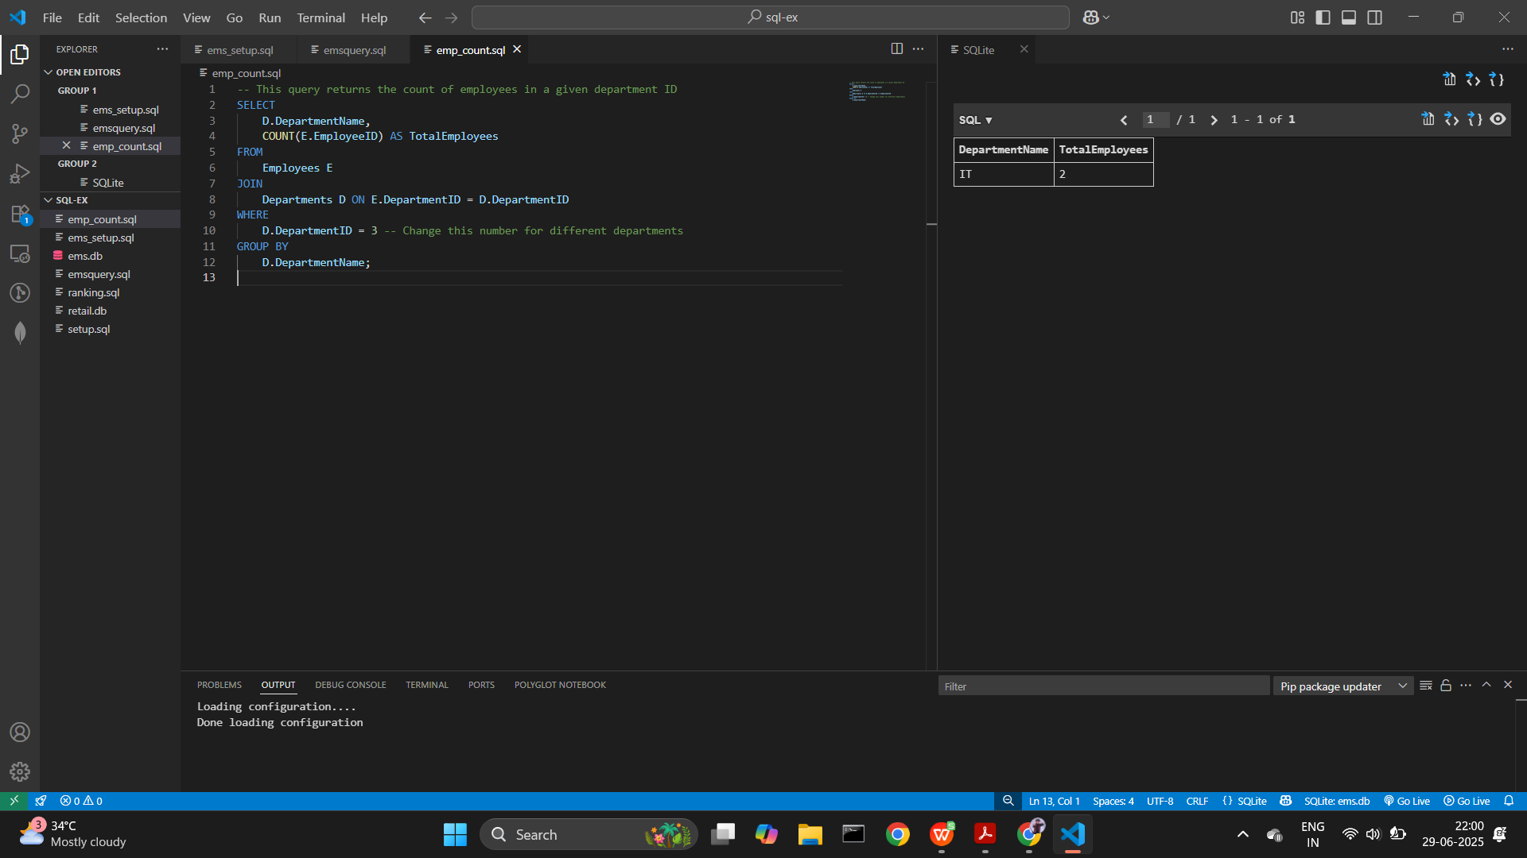

# Conclusion

Although SQLite does not support stored procedures, we achieved the functionality using standard SQL queries.